Ahmad Barakat | ITEC 422 | Wireshark 8

- Sources for first 8: STP -> HSRP -> ARP (3 times) -> STP -> BROWSER -> HSRP

- Identify record type
Version - Specifies SSL/TLS protocol version (TLS 1.2 = 0x0303)
Length - Indicates size of encrypted payload (max 16384 bytes in TLS 1.2)

- 0x16
- Yes, 1954281010
- Yes, advertises supported cipher suites, can’t find
- Yes,
- Yes, record includes a nonce, 32 bytes, adds randomness to prevent replay attacks.
- Yes includes a session ID, allows resumption without full handshake
- No, the certificate is in a separate record.
- Yes, it contains a Pre-master secret. Used to generate the master secret for session keys, encrypted, Length: 132 bytes
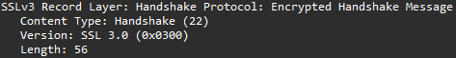
- The finished handshake message, using new session keys in the handshake
- Yes, both confirm that the sides are now using encryption
- Yes, wireshark only shows application data and doesn’t separate encrypted message and the MAC
- Session resumption makes reconnecting faster.

